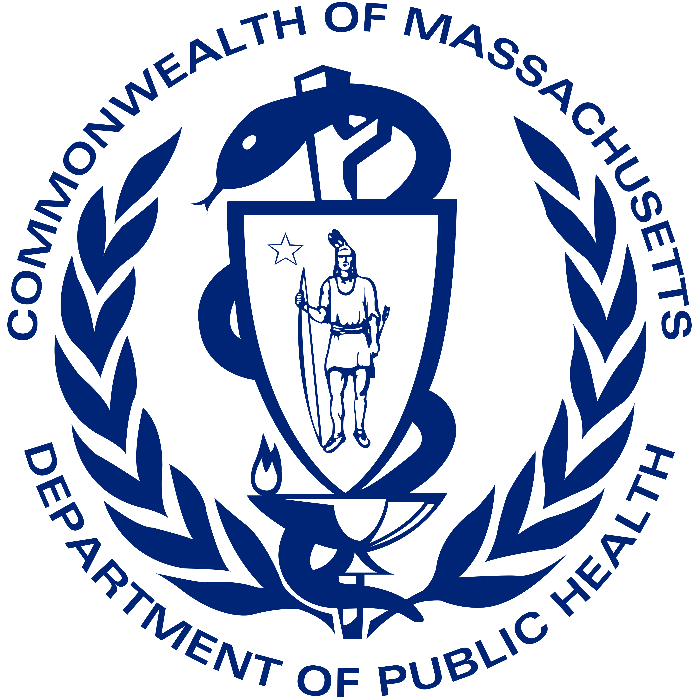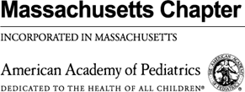
November 1, 2022

Dear Families,
The Commonwealth, the Northeast and much of the US are seeing increases in respiratory illness in infants and children. Some of these infants and children are requiring hospitalization for support with breathing and hydration. Emergency departments and other acute care health facilities have been managing significant increases in the number of patients requiring care.
Most of these illnesses are caused by respiratory viral infections, including common seasonal viruses like respiratory syncytial virus (RSV), rhinovirus and enterovirus, and influenza. Infants and children may be particularly susceptible to seasonal respiratory viral infections during the 2022-2023 fall and winter because they have had limited previous exposure to these respiratory viruses. We anticipate that there could be more respiratory illnesses as RSV continues to spread and influenza season ramps up.
The Department of Public Health and the Massachusetts Chapter of the American Academy of Pediatrics want to remind parents and families about steps to take to prevent illness and stay healthy this season:
- Vaccinate your children ages 6 months and older against influenza as soon as possible.
- Vaccinate your children ages 6 months and older against COVID-19; children 5 and older who had their primary series more than 2 months ago should receive an updated COVID-19 booster as soon as possible.
- Remember, you can get a COVID-19 vaccine and flu shot at the same time.
- If your infant has been offered treatment with protective antibodies due to their prematurity or another condition, keep on schedule with their monthly treatments.
- Practice hand hygiene frequently with soap and water or hand sanitizer. Cover coughs and sneezes with a tissue, or if a tissue is not available, cover them with an elbow, not a hand.
- Clean high touch surfaces in your home frequently with household disinfectants.
- Keep children home from daycare or school who have fever, especially with a cough, difficulty breathing or shortness of breath, congestion, runny nose, or sore throat, until they are fever-free for 24 hours without medications that reduce fever.
- Avoid social gatherings if you or your children are ill.
- Contact your pediatrician or healthcare provider if you believe your child needs medical care. Your provider can offer advice on whether your child needs to be evaluated in person, tested for COVID or flu, and the best location (doctor’s office, urgent care, emergency room) for care.

Thank you for doing all you can to keep you and your family healthy during this fall and winter season.
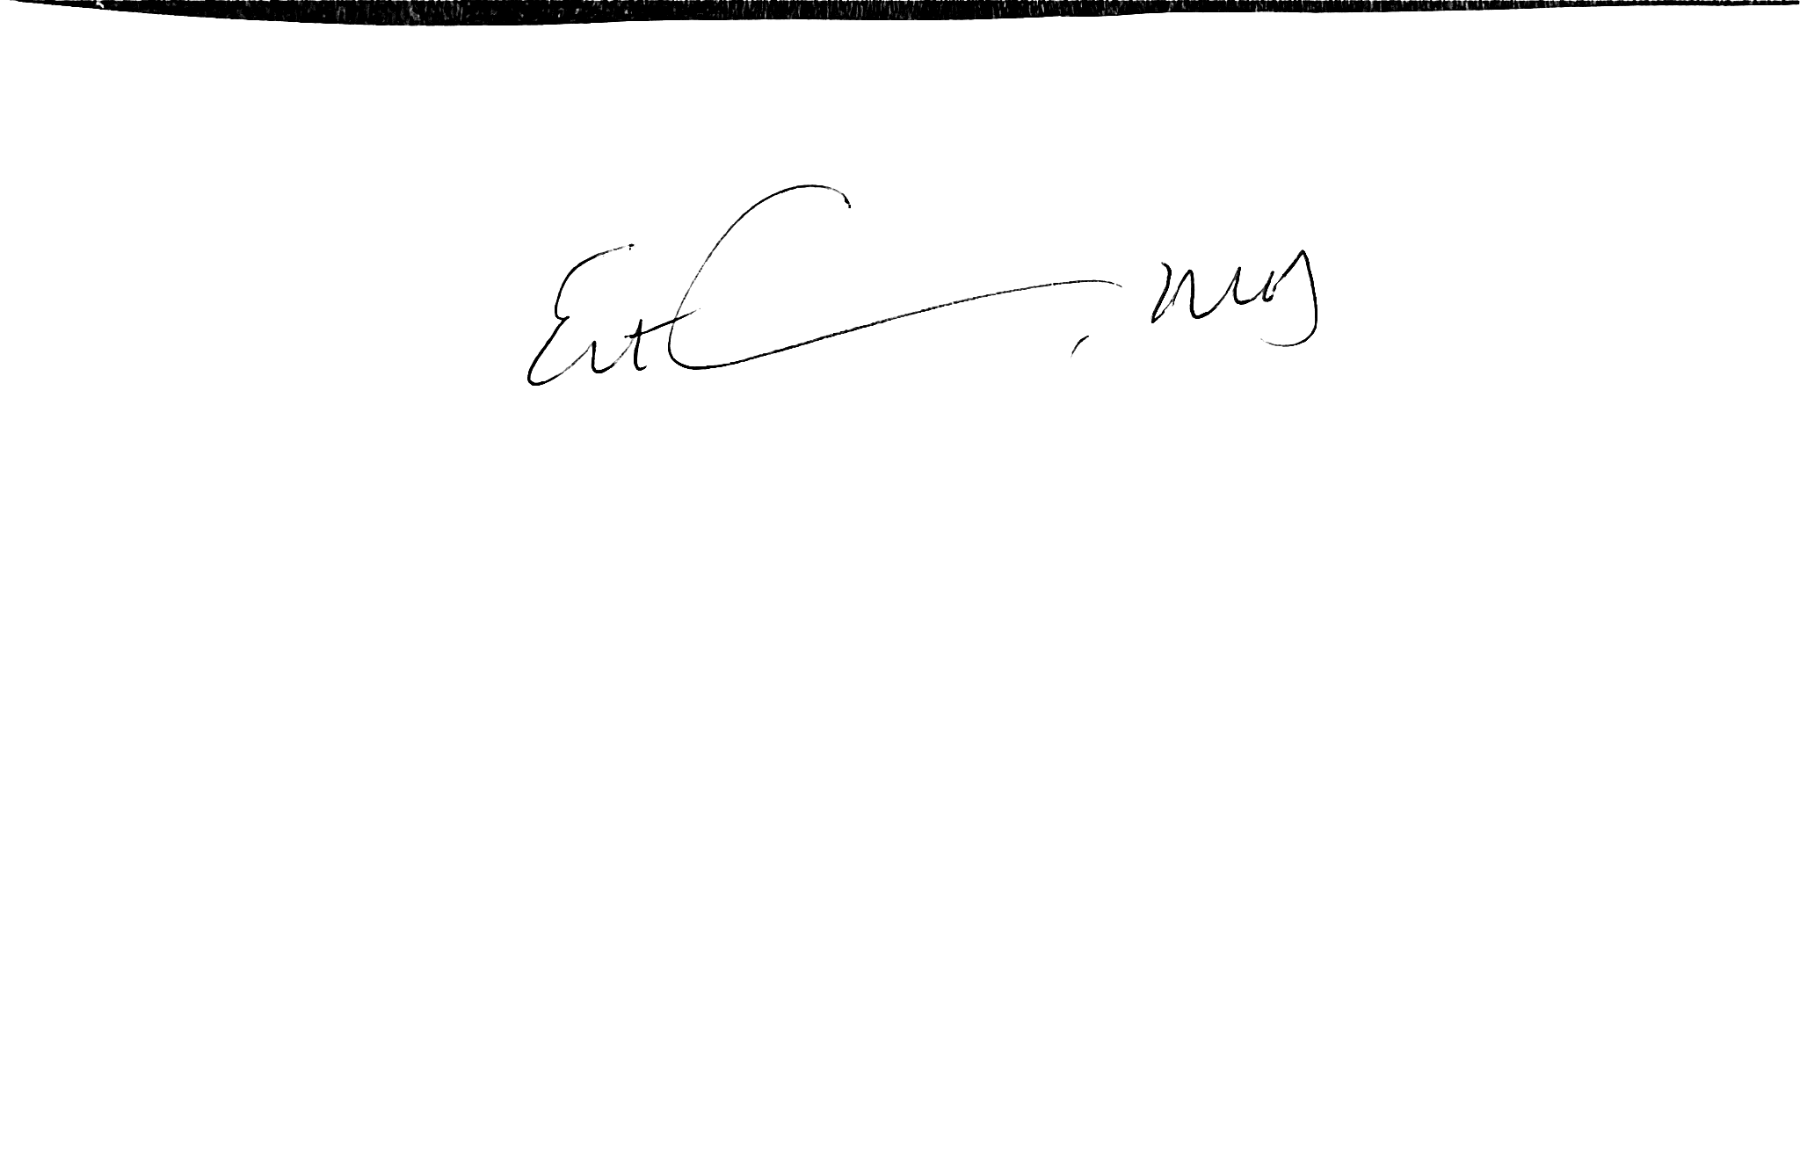
Dr. Estevan Garcia, Chief Medical Officer
Massachusetts Department of Public Health


Dr. Mary Beth Miotto, President
Massachusetts Chapter of the American Academy of Pediatrics

